Monday, 9 November, 2020

Dear Parents/Carers and Interested parties,

**Admissions Policy Consultation – Burton Joyce Primary School**

Burton Joyce Primary School, alongside all schools in Equals Trust is consulting over minor changes to its Admissions Policy for 2022-23.

All the schools in Equals Trust are required to adopt their own Admissions policies, with any decisions implemented in time for applications from September 2022. In order for this to take place, we need to consult with parents, carers and any other interested parties.

We have written a draft Admissions policy for Burton Joyce Primary School which explains the procedures for admissions to the school. This draft closely follows our current Admissions policy, with an amended oversubscription criteria. The new proposal (in order of priority) is:

1. Looked after children and previously looked after children.
2. *Children who have been adopted from state care outside of England.\**
3. Children who live in the catchment area at the closing date for applications and who, at the time of admission, will have a brother or sister attending the school.
4. Other children who live in the catchment area at the closing date for applications.
5. Children who live outside the catchment area who, at the time of admission, will have a brother or sister attending the school.
6. Children who live outside the catchment area.

* *The addition of this criterion is due to the DfE notifying admissions authorities of their intention to amend the Admissions Code (2014) to include this as standard. In the meantime, all admissions authorities have been asked to include it in their oversubscription criteria.*

We strongly believe that the criteria listed for the school will help allocate places in a fair, clear and objective way.

Additionally, the draft Admissions policy makes clear the definition of ‘Special Consideration’ for families who have circumstances which are not considered in the Admissions Code (2014). Parents are often confused regarding what constitutes ‘Special Consideration’ and consequently we have included a definition and process for considering this, including how we work alongside Nottinghamshire County Council if evidence was resented.

If you would like to read the draft Admissions policy for Burton Joyce Primary School, it is published on the school website at **www.burtonjoyce.notts.sch.uk** We welcome and invite you to send comments regarding the draft policy to [enquiries@equalstrust.org](mailto:enquiries@equalstrust.org) Alternatively, you may submit written comments to the school office in a sealed envelope, labelled ‘Admissions policy consultation’.

The consultation period will run from Monday 2 November, 2020, until Monday, 13 December, 2020. After the consultation period is finished, a decision will be made by governors whether to adopt the draft policy or not, and we will inform you of it in due course.

Admissions procedures for the school will still be co-ordinated by Nottinghamshire County Council and parents will still apply for a school place through their website at [www.nottinghamshire.gov.uk/schooladmissions](http://www.nottinghamshire.gov.uk/schooladmissions) We will continue to work in partnership with Nottinghamshire County Council in regard to all admissions applications and procedures.

Yours faithfully

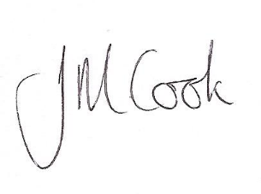

Jenny Cook

**Headteacher, Burton Joyce Primary School**

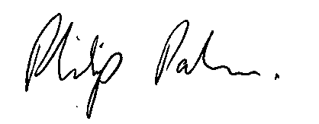

Phil Palmer

**Chief Executive Officer, Equals Trust**